**LOW-LEVEL DESIGNS DOCUMENT**

**Hubba - Logout**

Version 1.0

Prepared By: Development Hell

Class: CECS 491-04

Date: January 29, 2023

Github Repository**:**

[**https://github.com/DevelopmentHellaHell/SeniorProject**](https://github.com/DevelopmentHellaHell/SeniorProject)

**Team Leader**

Kevin Dinh

**Members**

Garrett Tsumaki

Bryan Tran

Jett Sonoda

Tien Nguyen

Darius Koroni

**Revi**[**sion History**](https://github.com/DevelopmentHellaHell/SeniorProject/tree/main/TrainE_ProjectProposal)

| **Version** | **Overview** | **Date** |
| --- | --- | --- |
| v.1.0 | Initial LLD | 1/29/2023 |
|  |  |  |

# Table of Contents

**Table of Contents** **3**

**High-Level Design** **4**

**Low-Level Design** **4**

Successful Use Cases 5

Failure Cases 6

**References** **7**

# High-Level Design

Activity flow - Client request Logout:

[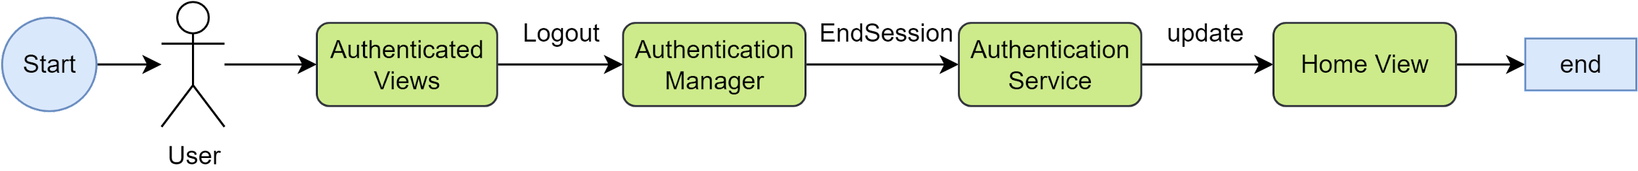](https://app.diagrams.net/?page-id=C5RBs43oDa-KdzZeNtuy&scale=auto#G1dXOH4TJamngh3tJhmtC-f1rMpDpcYGXH)

# Low-Level Design

**User story**: As a verified user, I can log out by sending a logout request. System will navigate me to the Home view after logging out successfully.

**Business rules**:

1. Any authenticated user can request logout to end their active authenticated session.
2. System failure from this feature will not cause the system to go offline.

**Preconditions**:

1. User must be authenticated and has an active session on the current device. If not, this operation is not an option to view.
2. User must be on view with the Logout option.

## Successful Use Cases

1. User performs logout request. The active session ends. The user is automatically navigated to the default home view of the system with the default culture settings. A system message displays “Logout successfully” upon completion of automatic navigation to home view. The logout process completes within 5 seconds upon invocation.
2. If the user is not authenticated, then the system should not allow log out.

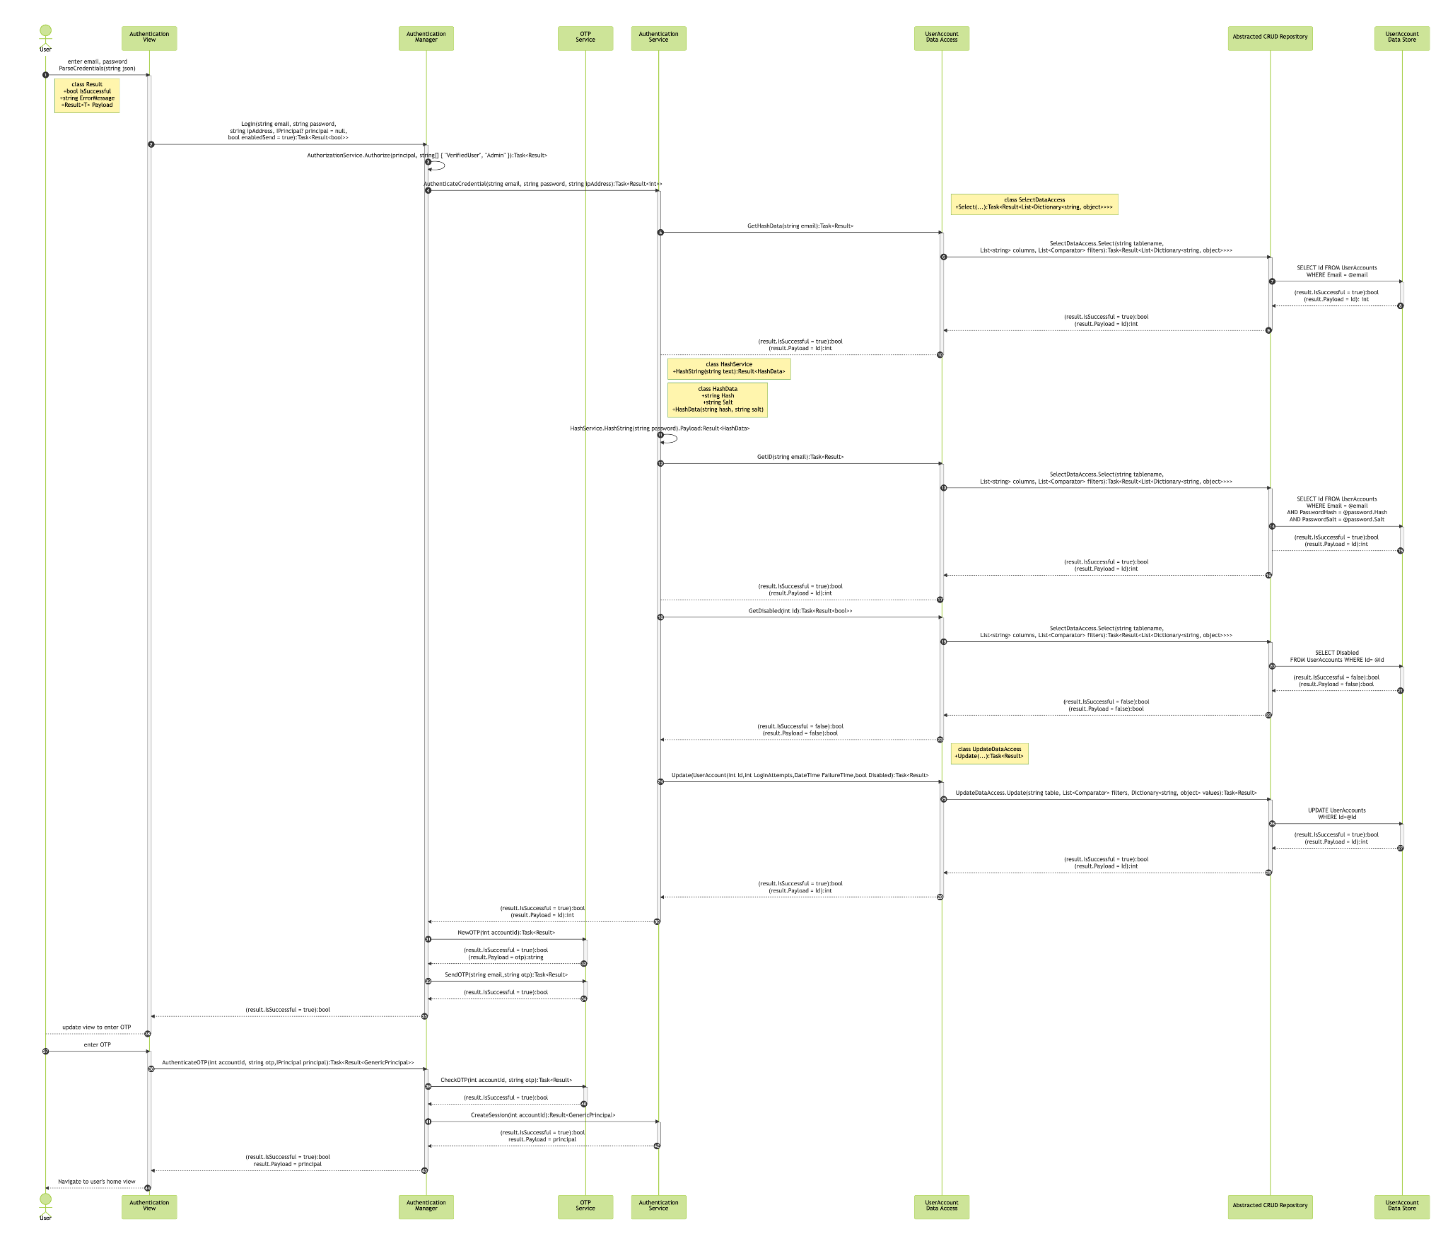

* Steps 31-34 and 39-42, reference OTP Low-Level Design Document

## Failure Cases

1. User performs logout request. The active session has ended. The user is not automatically navigated to the default home view. A system message displays “Logout operation error” or no message is shown

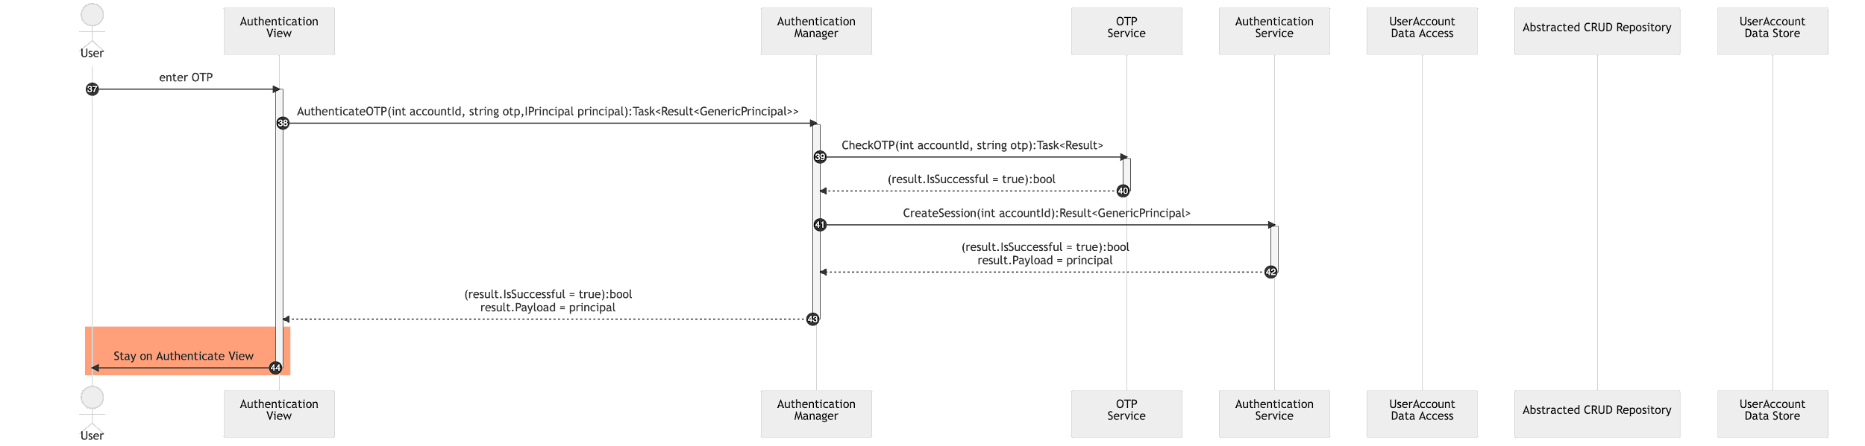

2. User performs logout request. The active session has ended. The user is automatically navigated to the default home view, but not set to the default culture settings. A system message displays “Logout operation error” or no message is shown

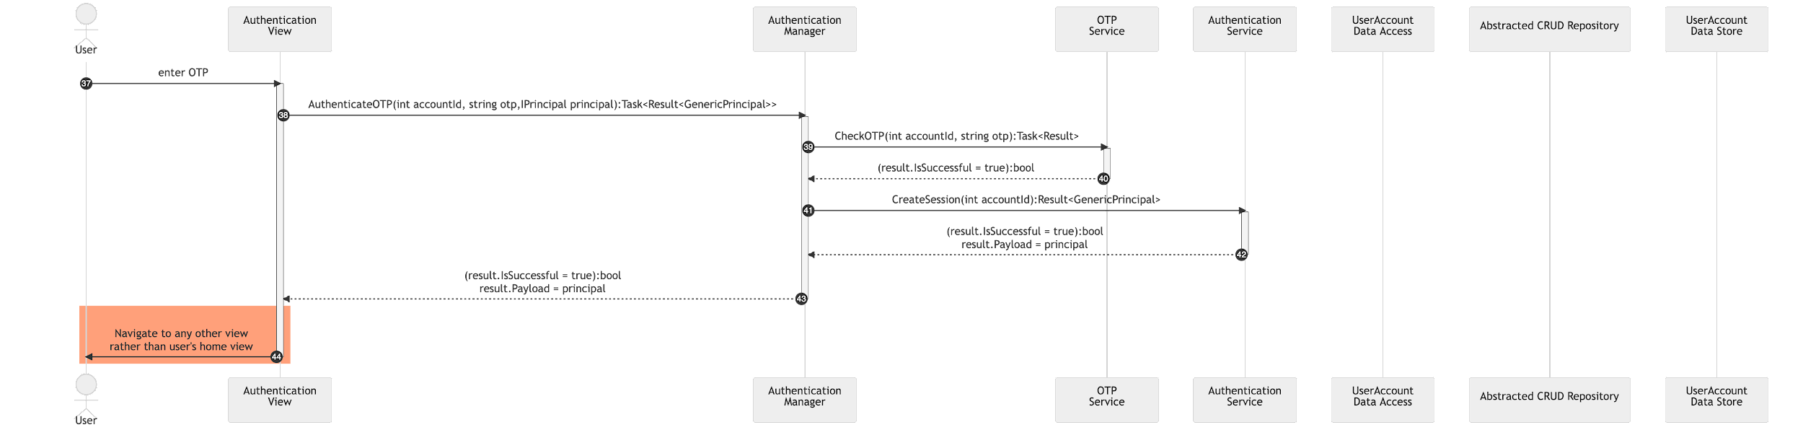

3. The logout process takes longer than 5 seconds.

{"theme":"neutral","source":"sequenceDiagram\n    autonumber\n    actor u as User\n    participant v as Authentication<br/>View\n    participant m as Authentication<br/>Manager\n    participant os as OTP<br/>Service\n    participant s as Authentication<br/>Service\n    participant da as UserAccount<br/>Data Access\n    participant r as Abstracted CRUD Repository\n    participant ds as UserAccount<br/>Data Store\n\n    u->>+v: enter email, password<br/>ParseCredentials(string json)\n        \n        v->>+m: Login(string email, string password,<br/> string ipAddress, IPrincipal? principal = null, <br/>bool enabledSend = true):Task<Result<bool>>\n            m->>m: AuthorizationService.Authorize(principal, string[] { \"VerifiedUser\", \"Admin\" }):Task<Result>\n            m->>+s: AuthenticateCredential(string email, string password, string ipAddress):Task<Result<int>>\n                \n                s->>s: ValidationService.ValidateEmail(string email):Task<Result>\n                s->>s: ValidationService.ValidatePassword(string password):Task<Result>\n                \n                s->>+da:  GetHashData(string email):Task<Result>\n                    da->>+r: SelectDataAccess.Select(string tablename,<br/>List<string> columns, List<Comparator> filters):Task<Result<List<Dictionary<string, object>>>>\n                        r->>+ds: SELECT Id FROM UserAccounts <br/>WHERE Email = @email\n                        ds-->>-r: (result.IsSuccessful = true):bool <br/>(result.Payload = Id): int\n                    r-->>-da: (result.IsSuccessful = true):bool <br/>(result.Payload = Id):int\n                da-->-s: (result.IsSuccessful = true):bool <br/>(result.Payload = Id):int\n\n                s->>s: HashService.HashString(string password).Payload:Result<HashData>\n\n                rect rgb(255,160,122)\n                s->>+da:  GetID(string email):Task<Result>\n                    da->>+r: da->>+r: SelectDataAccess.Select(string tablename,<br/>List<string> columns, List<Comparator> filters):Task<Result<List<Dictionary<string, object>>>>\n                        \n                        r->>+ds: SELECT Id FROM UserAccounts <br/>WHERE Email = @email\n                        ds-->>-r: (result.IsSuccessful = false):bool <br/>(result.Payload = \"Invalid email\"):string\n                    r-->>-da: (result.IsSuccessful = false):bool <br/>(result.Payload = \"Invalid email\"):string\n                da-->-s: (result.IsSuccessful = false):bool <br/>(result.Payload = \"Invalid email\"):string\n                end\n            \n            s-->>-m: (result.IsSuccessful = false):bool <br/>(result.Payload = \"Invalid email\"):string\n        \n        m-->>-v: (result.IsSuccessful = false):bool\n\n    v-->-u: Display message: <br/>“Invalid username or password provided. <br/>Retry again or contact system administrator”"}

# References

This document elaborates client’s requirements[1] for one of the product’s core components - LOGOUT.

The requirement is designed based on the system architecture provided in High-Level Design Document[2].

The diagrams included in this document utilized diagrams.net[3] and Mermaid.js[4].

1. Client’s email, 10/17/2020
2. High-Level Design Document, URL: https://github.com/DevelopmentHellaHell/SeniorProject/blob/b43182c4076d471ef03520052675f1f88371dafd/docs/HL%20Design/DevelopmentHell%20HLD%20v1.2.pdf
3. https://www.diagrams.net/
4. https://mermaid-js.github.io/mermaid/#/